International Week will take place in two buildings of Saint-Petersburg State University of Aerospace Instrumentation:

- Main building
Address: Bolshaya Morskaya st., 67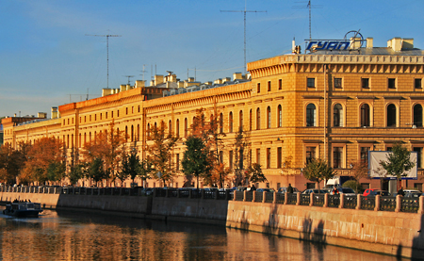

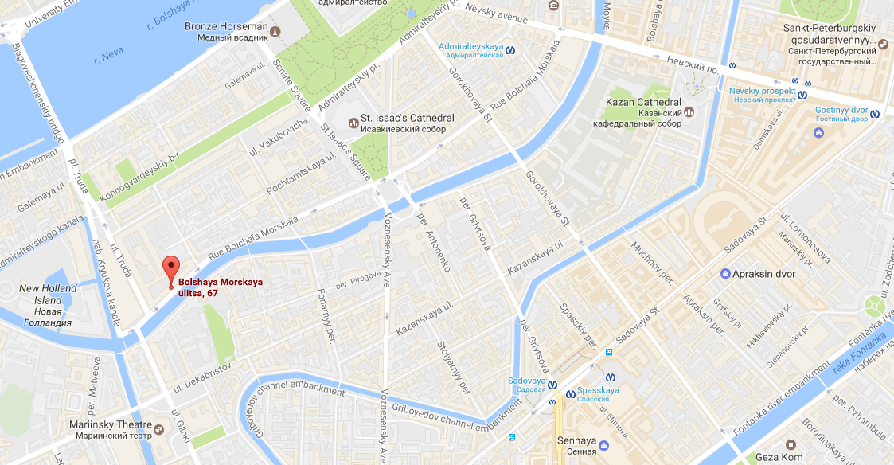

2) Another building
Address: Lensoveta st., 14
