001
12.09.2023
Together into the future: SUAI will cooperate with Shanghai University of Engineering Sciences
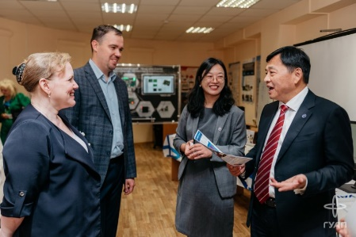
A delegation from China representing Shanghai University of Engineering Sciences (SUES) visited our university and got acquainted with the main areas of study and research
The relationship of St. Petersburg State University of Aerospace Instrumentation with Chinese universities has always been close. The pandemic has minimized personal contacts, but now we are ready to resume the cooperation.
On September 12, a delegation from Shanghai University of Engineering Science (SUES) visited SUAI to discuss and outline joint steps for further cooperation.
SUAI Vice-Rector for Academic Affairs Valery Matyash welcomed the guests from China presenting the information about the SUAI main areas of study and research.
Vice-Chairman of the University Council of Shanghai University of Engineering Sciences Shi Jianyong shared the presentation about SUES - one of the 200 universities and colleges approved by the Ministry of Education of the People's Republic of China for the admission of foreign students, accepting students from more than 30 countries. SUES boasts both a deep academic profile and interaction with many Chinese partner enterprises. The representatives of the delegation expressed hope that SUAI will soon become a university with which close cooperation will be established in the nearest future. In October, the SUAI delegation headed by the rector plans to visit Shanghai, and a visit to the Shanghai University of Engineering Sciences is also planned. Universities plan to consolidate the idea of cooperation by signing a memorandum of understanding.

002
07.09.2023
SUAI at UNESCO Digital Learning Week
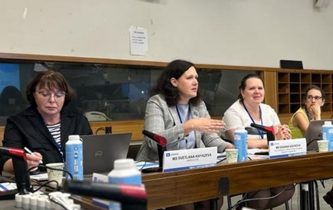
On September 5 to 7, the UNESCO Headquarters hosted the Digital Learning Week, which was a continuation of the UNESCO Mobile Learning Week, held annually for the past 10 years
This new annual UNESCO flagship event on digital learning includes a set of events aimed at uniting politicians, practitioners, teachers, private sector partners, researchers and representatives of development agencies into a global community in order to jointly develop a further response to the new dynamics of digital learning. To manage the digital transformation in education, policy makers and practitioners need to develop models that ensure reliable management, maintenance and interaction of technology and people.
The UNESCO Institute for Information Technologies in Education invited the Deputy Head of the SUAI UNESCO Chair on Distance Engineering Education as an expert to speak at one of the key sessions with a report on the best practices of the SUAI Chair in the field of application of new technologies in education.
As a result of the Digital Learning Week activities a Guide to the use of generative AI in education and research was designed to help integrate generative AI into the educational sphere.

003
24.08.2023
SUAI scientists have created a distributed navigation system for microsatellites
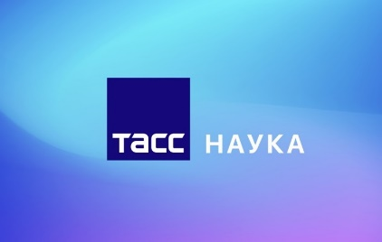
The development will make it possible to monitor the Earth's surface more efficiently and to organize operational communication systems in a better way.
The system uses an optical method for determining the relative position of satellites in a group. The accuracy and speed of the work make it possible to solve the tasks of navigation and flight control of satellites in real time. The main feature of the development are the optical markers (infrared LEDs) on the body of the device, which are detected by video cameras of neighboring satellites. To increase the recognition range, you need to place LEDs on retractable elements such as solar panels and radio antennas. This will increase the spatial base between the markers. Controlled modulation of LED operating modes and optimization of the width of the angular aperture of radiation are used to identify individual LEDs.
– The advantage of the system is the autonomy and high speed of work. We use new digital technologies to control onboard equipment – the technical vision, which helps to process images from video cameras on neighboring microsatellites, – said Nikolay Mayorov, director of the Institute of Aerospace Instruments and Systems of SUAI.

004
22.08.2023
How students’ ideas lead them into business
Students of St. Petersburg State University of Aerospace Instrumentation (SUAI) took part in the development of a project called VISION, which generates architectural and industrial design using artificial intelligence in 3D. The uniqueness of the product lies in the development of an automated solution, 3D engineering projects that allow to obtain drawings and renderings in the form of photos and videos, specifications, three-dimensional images in CAD and polygons in a short time.
Now the team interacts with a number of companies and educational institutions. In the next 2 years, the developers plan to occupy 10% of the industrial and architectural design market of the country, test the market outlets of China and India and expand their positions.

005
22.08.2023
A new system of protection of power line wires with the help of robots developed in SUAI
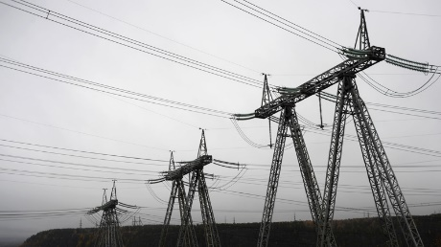
According to the Ministry of Education and Science of the Russian Federation, robots will be able to both clean the wires from snow and ice, and report on the condition of the wires
The development allows to track even microcracks, which can destroy the insulator or the fastening of power lines. The robot also detects the slope of the power transmission poles and tracks the dynamics of the deviation, which allows preventing a rapid fall and breakage. The development is adapted to the Russian power supply system. In other countries, there may be specific wiring arrangements on supports, other wind loads and other factors.
— There are no ready-made mass solutions in the country at the moment. In the USA, China, Canada, the Netherlands, research is being conducted on this topic, but the samples obtained are heavy and clumsy, and are designed to move from one main plank to another. In Russia, there are similar developments using flying drones, but the methods of measuring indicators for accuracy cannot be compared with the contact methods of a robot developed at SUAI," said Alexander Rysin, senior lecturer at the Department of Electromechanics and Robotics at the Institute of Cyberphysical Systems of SUAI and head of the Robotics Laboratory at the University's School of Engineering.

006
29.07.2023
Delegation of the Republic of Zimbabwe in SUAI
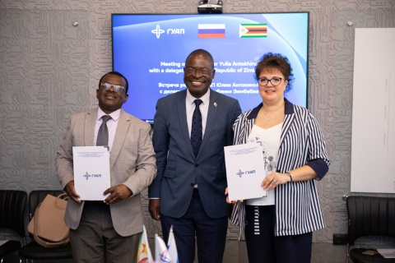
A meeting with representatives of the higher education sector of the Republic of Zimbabwe was held at the St. Petersburg State University of Aerospace Instrumentation.
Last year prospects for cooperation between Russia and Africa in the field of space were outlined when in November 2022, representatives of Roscosmos and the Minister of Higher and Vocational Education, Innovation, Science and Technological Development of the Republic of Zimbabwe, Amon Murvira, agreed to cooperate on the creation and launch of small spacecraft.
On July 29, a delegation from Zimbabwe headed by Dr. Amon Murvira visited the St. Petersburg State University of Aerospace Instrumentation. The delegation included representatives of the Ministry of Higher Education, Innovation, Science and Technological Development of the Republic of Zimbabwe, rectors and deans of universities, as well as employees of the National Geo–Spatial and Space Agency of Zimbabwe and those responsible for innovative research and development. The purpose of the visit was to get acquainted with developments, research and the scientific potential of SUAI.
During the visit, four memoranda of understanding were signed. The start of relations in the field of science and education has been laid, joint work and projects are ahead.

007
04.07.2023
The second SUAI-PSU International Summer School has completed its work
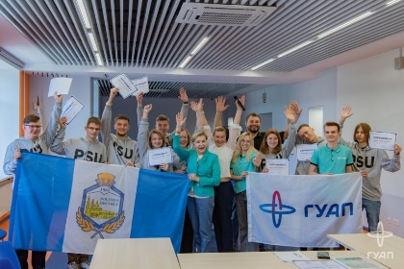
From June 19 to 24, students from the Republic of Belarus became guests of St. Petersburg and participants of the SUAI-PSU International Summer School on Information Technologies and Robotics, where they got acquainted with the work of the laboratories of our university and gained new knowledge.
The students of Polotsk State University named after Euphrosyne of Polotsk have a busy week behind them. The Summer School program included presentations of SUAI laboratories, lectures, a visit to the Power Machines – SUAI student constructor bureau, as well as a visit to the most beautiful sights of St. Petersburg in the company of SUAI Welcome Center guides.
Timofey Gulevich, PSU Design and production of software-controlled electronic devices student, shared his impressions:
– Of all the events, I would like to highlight a visit to the mobile robot laboratory and the Engineering garage. I have several ideas that I plan to implement and in order to do it I will need the knowledge that I have acquired here. I also really liked the Power Machines student design bureau. SUAI has many well-equipped laboratories and a good technical base. I plan to work either in the direction of robotics, or become an embedded systems programmer. All the knowledge I have gained will be useful to me.
The participants also liked the training on Emotional Intelligence conducted by Anastasia Zhivykh, coach of the SUAI Competence Center. The training allowed them to get to know each other better, unite the team and identify leadership qualities.
At the end of the event, students from Belarus were awarded certificates of participation and gifts.

008
04.07.2023
"Modern Ontology - XI: Ontology and Religion" International Scientific and Practical Conference
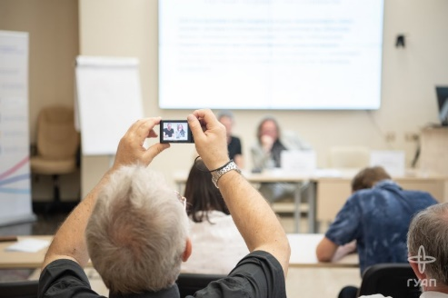
From June 26 to 30, SUAI hosted a large–scale international scientific and practical conference on Modern Ontology - XI: Ontology and Religion. The scientific program includes two blocks
This year the Conference was organized by the St. Petersburg State University of Aerospace Instrumentation, Volgograd State University and the Ontological Society. More than 110 scientists, from Russia, Republic of Belarus, Lithuania, and China, took part in this large-scale event.
The organizers noted that the concept of the Conference implies ontology not only as a basic section of philosophy, but also as knowledge about the world as a whole. Ontology reflects all aspects of being, including religion.
The reports of the first block of the scientific conference include such areas as the ontological foundations of the emergence of religion, its purpose, prospects for the union of ontology and religion. The topics of the second block covered the theory of ontology and it’s history, speakers talked about the relationship of ontology and mathematics, natural sciences, humanities, theology and angelology, as well as about the logic, ethics, aesthetics, philosophy of religion.

009

23.06.2023
8 PhD students and 14 students of SUAI became winners of the grant competition
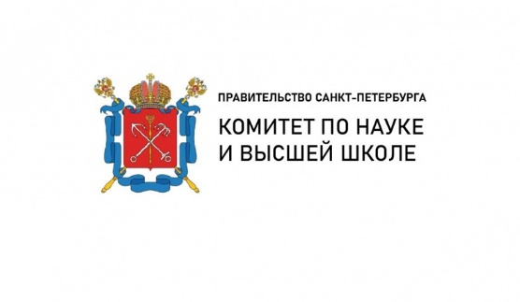
The Committee on Science and Higher Education summed up the results of the annual grant competition for students of universities and academic institutes located in St. Petersburg. This year, SUAI students received a record number of awards. – My work is devoted to the development of a model for predicting the development of a sea passenger port using unmanned aircraft systems to build digital models, – says Angelina Dobrovolskaya, SUAI PhD student, – I have been researching this topic for a long time: the beginning was laid in my master's thesis, which was devoted to digital models. Now, as a PhD student, I continue to work in the port infrastructure sphere. The sea passenger port, like any other object, needs development which should be based on up-to-date data on the state of the infrastructure and its workload. The most suitable tool for this is modeling. The passenger port is a significant object for both the city and the country, and new approaches and models are needed to predict its development under changing external factors. I decided to engage it science because I really wanted to achieve big heights and contribute to the development of at least my city. The CSHE competition is a great motivation to continue working on a project and promote it further.
Yana Ryvkina, a student of the Institute of Radio Engineering and Infocommunication Technologies of SUAI, shares about her project – a fire detection system:
– I presented a fire detection system that is able to detect a fire at the smoldering stage. This is due to the detection of heat flow and smoke. When they appear, the refractive index changes, which can be registered using laser radiation. Modern sensors work rather slowly, as they detect deflagration products. With our technology, it will be possible to detect a fire faster, thereby avoiding both financial and human losses. In addition, the system can be used in explosive rooms, since we do not have open current-carrying elements.
We congratulate the winners and wish them further success and new discoveries!

010
18.06.2023
SUAI students from China visited the Gatchina Museum of the History of Aircraft Engine Building and Repair
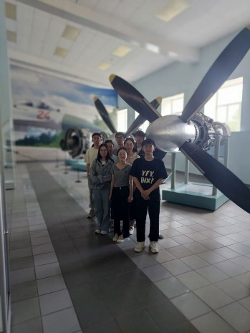
On June 18, SUAI students studying at the Department of Operation and Management of Aerospace Systems visited the Gatchina Museum of the History of Aviation Engine Building and Repair.
At the Museum a practical lesson was held on full-scale models of various types of aircraft engines. The students got acquainted with the design features and the history of the development of Soviet aircraft engines of airplanes and helicopters. After visiting the museum, the students visited the park ensemble of the Great Gatchina Palace.

011
16.06.2023
Glasses with tactile response for navigation for blind and visually impaired people have been developed in St. Petersburg
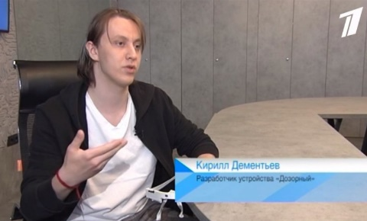
Students of the St. Petersburg State University of Aerospace Instrumentation (SUAI) have developed a digital navigator for blind people - rim glasses with tactile response.
The device called Dozorniy is cheaper and easier to use than well-known analogues. It is noted that Dozorniy will be able to complement the tactile cane, protecting a person from threats above knee level. Among the advantages of the project are versatility on the street and indoors, small size, weather adaptation, as well as the hands free principle. This device is cheaper compared to similar offers on the market, and is more compact, faster and easier to use.

102
16.06.2023
SUAI students have developed an advanced posture corrector
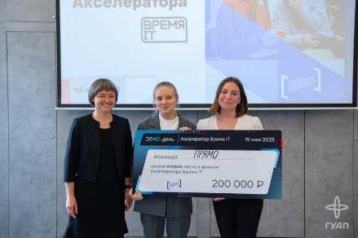
The “Accelerator. It’s IT time” project has been completed at the St. Petersburg State University of Aerospace Instrumentation. Teams of participants worked on technological projects in the IT field, and the industrial partners selected those students' developments that might become an indispensable part of the new technological reality. ne of the winning projects was a device aimed at correcting the posture of schoolchildren.
- This development is a corset that gives a vibration response when a person slouches. The user receives a vibration warning letting him or her know that it is necessary to straighten up, and if the person has not straightened up after 30 seconds, they receive a second warning. If this did not help, the corset brings the posture to the correct position and holds it for a while, - says Yulia Maliavina, the author of the project.
The main difference from existing analogues is that the corset does not just remind you that it's time to straighten your shoulders, but forms the correct posture. IT brings the posture to a normal position almost without any human intervention and holds it.
In the process of working on the project, the team constantly consulted with an experienced orthopedic doctor. The work went on gradually - first the team developed the corset itself, and then a mobile application with basic functions was created. With its help, the principle of gamification was implemented: the game approach allows you to interest the user, especially children and teenagers who are the target audience of this product. The application reminds of the familiar game "tamagotchi" - in order to feed a pet, the user performs a series of physical exercises to form posture. You can also use Bluetooth to transfer data to a mobile app to track your results and get motivated to use this robotic device.

013
15.06.2023
SUAI enters TOP 100 of the National University Ranking
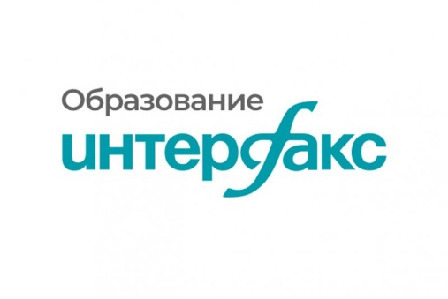
The Interfax Information Group has published the results of an annual study.
The purpose of the rating is to evaluate the activities of Russian universities that meet the standards and are world models in the field of education, research, innovation and humanitarian development. The assessment is formed using six indicators: Education, Research, Social environment, Cooperation, Innovation and Entrepreneurship, Brand.
In total, 368 educational institutions were represented in the National University Ranking 2023 and according to the results, SUAI entered the TOP 100 Russian universities.

014
14.06.2023
The University ranks 14th in the ranking of salaries among young IT professionals
The Superjob Research Center has published a comparative rating of Russian universities by the average income level of graduates in 2017-2022. SUAI has risen by two positions since last year. In 2022, the University occupied the 16th position, and this year – 14. Over the year, the average salary increased by 25,000 rubles and amounted to 145 000 rubles Among the indicators also taken into account were the number of graduates who have found a job in the city where they studied. 84% of SUAI students found a job in St. Petersburg.
The Institute of Information Technology and Programming is responsible for the training of IT specialists at SUAI. Bachelors, specialists and masters are graduates receive applied skills in the field of computing machines, complexes, systems and networks, computer software and automated systems, mathematical support and administration of information systems, mathematical modeling, computer science and computer technology, electronic devices and systems.
A lot of research work is carried out at the Institute. The learning process is designed in such a way that students have the opportunity to master a large number of competencies from microprocessor systems to virtual and augmented reality.

015
06.06.2023
An exo-glove developed by SUAI student
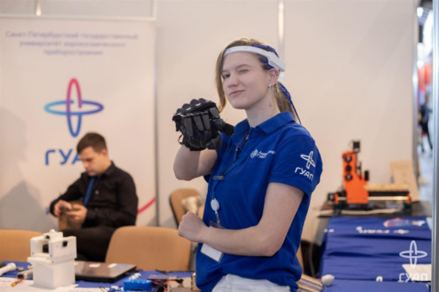
Tatiana Ushakova, the 4th year SUAI student, has developed an exo-glove - an anthropometric model of a wrist grip booster. The body of the exo-glove is printed on a 3D printer and is made of high-strength plastic. It is heat resistant and has high durability. The glove protects against cuts and scratches and strengthens the wrist grip with the help of its engines.
The device is controlled in two ways: tactile — by pressing buttons or touch panels, as well as through pulse-reading gel electrodes, - says Tatiana
According to the original idea, the exo-glove was intended to facilitate the rehabilitation of people, but now the developers see it as an assistant for workers of industrial and manufacturing enterprises — it is assumed that it will help when handling warehouse cargo or other dimensional objects.

016
05.06.2023
SUAI student won the «I Am a Professional» Olympiad
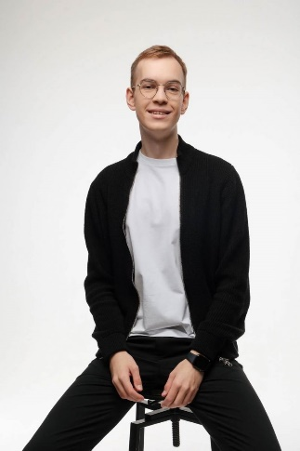
Igor Frolov, a student of the St. Petersburg State University of Aerospace Instrumentation, won the sixth season of the All–Russian Olympiad of Students "I am a professional" in the 2022/2023 academic year
Igor Frolov, a student of the St. Petersburg State University of Aerospace Instrumentation, won the sixth season of the All–Russian Olympiad of Students "I am a professional" in the 2022/2023 academic year
A student of the SUAI Institute of Entrepreneurship and Law Technologies performed in the Bachelor's Degree category in the direction of "Design". From December to April, he took an active part in the activities of the Olympic and presented a project on inclusion-based activities.
– I created an online application to unite volunteers – a single community to help people with disabilities. I developed the layout of the application, its architecture, how it will work from the point of view of the product and design: buttons, icons, application screens and more. Then I was engaged in promotion – how this service will be advertised, how users will interact with it, – Igor Frolov shared.
The Olympiad experts highly appreciated the performance of Igor. This victory helped Igor to receive benefits for admission to a master's degree in Design, as well as the opportunity to complete an internship in a large company.

017
05.06.2023
The XXVI International Scientific Conference on Wave Electronics and Infocommunication Systems
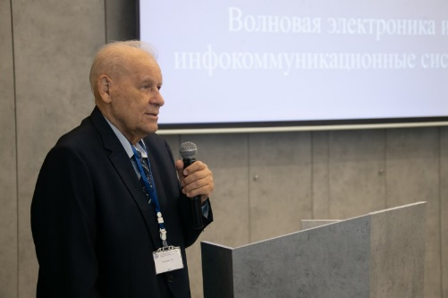
From May 29 to June 2, SUAI hosted the XXVI International Scientific Conference on Wave Electronics and Infocommunication Systems. The conference brought together the world's leading scientists, students, and postgraduates.
Wave electronics occupy a leading position Among the modern areas of scientific research. Wave-based devices are used in modern information and telecommunication systems, medical equipment, security and fire systems, monitoring systems, industrial equipment.
Over the years, the Conference has made a long way of transformations and organizational formats from three sections devoted to wave electronics to a large interdisciplinary platform where scientists gather to discuss the development of modern acousto-optics and acousto-electronics, information processing devices, infocommunications and intelligent transport systems.
More than 350 scientists from Russia and foreign countries (Belarus, Azerbaijan, Kazakhstan, Tajikistan, Germany, Iran, South Africa) took part in the Conference, 141 reports were presented in 9 sections.

018
02.05.2023
SUAI student wins 17th place in the All-Russian ranking of the TOP 1000 university startups
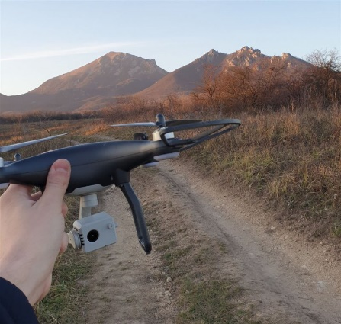
The All-Russian rating of the TOP 1000 university startups includes the most promising university stratup projects in such technological areas as digital technologies, new devices and intelligent manufacturing technologies, medicine, chemical technologies and new materials, resource-saving energy, creative industries and biotechnologies.
The "Smart vision" startup by Sergey Nenashev, a student of the Department of Computing Systems and Networks, took 17th place in the rating. It is dedicated to the development of a software product in the field of operational aviation and intelligent monitoring in disaster and emergency zones.
– The uniqueness of the product lies in the implementation of a specialized monitoring method using information channels from heterogeneous location sources, – says the author of the project. – Such large amounts of information will require the development of theoretical and applied methods for integrating data into one information field in order to obtain detailed and reliable information about the state of the observed surfaces and objects. This will allow us to develop highly reliable algorithms for assessing the state of observed objects and territories.
We congratulate Sergey on his significant achievement and wish him further success!

019
25.04.2023
A new Educational Factory for Electric Charging Stations in SUAI
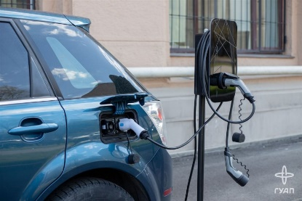
On April 25, within the framework of the Engineering School 2.0 strategic project of the Priority 2030 program, an Educational Factory for Electric Charging Stations named UNICUMMOTORS – GUAP was opened.
During the round table held within the opening events the representatives of partner companies and the university management discussed the prospects for the development of infrastructure technologies for electric charging stations.
Alexey Bobryshov, the head of the Educational Factory, said that the essence of the charging station is the control controller. The uniqueness of the SUAI developments consists in the logical control of charging. According to Alexey, most electric vehicles are not charged from charging stations or the network, but they analyze it. This module is responsible for the safety of the assembled switching circuit of the electric charging station. Alexey explained that the module interacts with the machine and redistributes energy. This helps to avoid problems when charging. He also spoke about the possibilities for students of creating home and business charging stations here in the Factory.
In addition to laboratory equipment, the Factory employees presented BYD - an Chinese electric car - a comfortable model with a soft suspension, outstanding aerodynamics and a power reserve of 320 kilometers.

020
21.04.2023
Forum “Russian modern avionics – 2023”
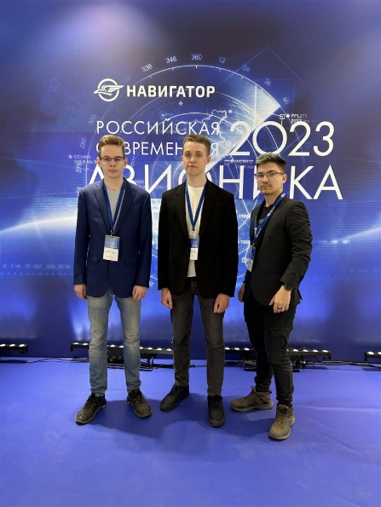
Next SUAI students took part in the Forum “Russian Modern Avionics – 2023” held in St. Petersburg on April 21.
The Forum was attended by leading representatives of the aviation and radio-electronic industry, aircraft and helicopter industries, developers and manufacturers of avionics equipment for aircraft, IT sector, specialists of research institutes and educational institutions.
Students of SUAI Engineering School: Vsevolod Shokalsky, Rostislav Burdakov and Andrey Shinkevich, were among the participants of the Forum. They are the developers of the Vertical project which participated in the crash test and Q&A session.
The Forum became an important event for the aviation and radio-electronic industry, where the latest developments were presented and topical issues were discussed. The Forum participants exchanged knowledge and experience, which will accelerate the development of the industry and increase the competitiveness of Russian developments on the world market.

